# Parse Log.gz

## Pretreatment

As KPI04-15_20181207192504_20181207193004_0019.log(OFFE00096385_PMD34EN A).gz for example. First we need decompress file, then we can see that the hexadecimal file reads as follows:

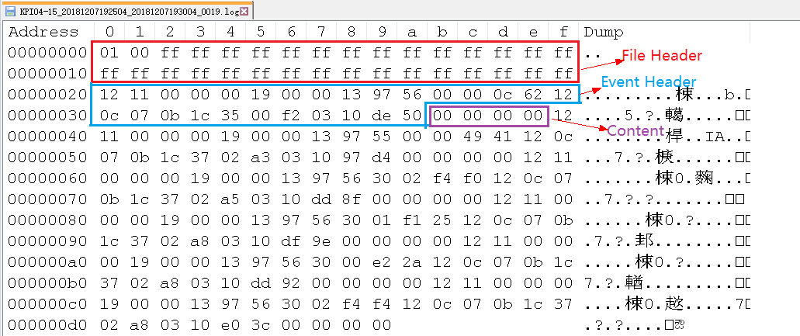

## Parse File as the Guide

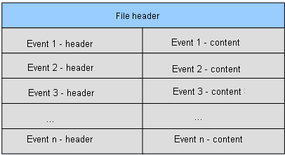

Format of LTE northbound result files

| Field | Data Type and Length | Description | Value（Hex） |
| --- | --- | --- | --- |
| Data Version | - | File format version information |  |
| >Main Version | UINT8 | Main version | 0x01 |
| >Sub Version | UINT8 | Sub-version | 0x00 |
| Spare | OCTET STRING (30) | Spare | 30 Bytes 0xFF |

Header format of LTE standard signaling files

| Field | Data Type and Length | Description | Introduced In | Value（Hex） |
| --- | --- | --- | --- | --- |
| Event ID | UINT16 | Event identifier | SRAN11.1  Pico 11.1 | 0x1211 |
| Event Length | UINT32 | Event length, excluding lengths of **Event ID** and **Event Length** | SRAN11.1  Pico 11.1 | 0x00000019 |
| eNodeB ID | UINT32 | eNodeB identifier. | SRAN11.1  Pico 11.1 | 0x00001397 |
| Cell ID | UINT8 | Cell identifier  Invalid value: all Fs. For example, the value of this field is invalid for base station events or cell events. | SRAN11.1  Pico 11.1 | 0x56 |
| Call ID | UINT32 | Call ID  Invalid value: all Fs For example, the value of this field is invalid for base station events. | SRAN11.1  Pico 11.1 | 0x00000c62 |
| Date Time | - | Time when an event is triggered  UTC time | SRAN11.1  Pico 11.1 |  |
| >Year | UINT8 | Difference between the current year and the year 2000 | SRAN11.1  Pico 11.1 | 0x12 |
| >Month | UINT8 | Month  Value range: 1 to 12 | SRAN11.1  Pico 11.1 | 0x0c |
| >Day | UINT8 | Day  Value range: 1 to 31 | SRAN11.1  Pico 11.1 | 0x07 |
| >Hour | UINT8 | Hour  Value range: 0 to 23 | SRAN11.1  Pico 11.1 | 0x0b |
| >Minute | UINT8 | Minute  Value range: 0 to 59 | SRAN11.1  Pico 11.1 | 0x1c |
| >Second | UINT8 | Second  Value range: 0 to 59 | SRAN11.1  Pico 11.1 | 0x35 |
| >Millisecond | UINT16 | Millisecond  Value range: 0 to 999  The value is **0** for events accurate to seconds. | SRAN11.1  Pico 11.1 | 0x00f2 |
| Extend Head Length | UINT8 | Extension header length | - | 0x03 |
| Item Type | BIT STRING (4) | Event type.   * **0000**: undefine * **0001**: FDD * **0010**: TDD * **0101**: NB-IoT * **1111**: Common | SRAN13.1 | 0x1 |
| Reserved | BIT STRING (4) | reserved | - | 0x0 |
| C-RNTI | UINT16 | C-RNTI  Invalid value: all Fs. For example, the value of this field is invalid for base station events or cell events. | SRAN11.1  Pico 12.0 | 0xde50 |

Format of an LTE standard signaling event header

| Field | Data Type and Length | Description | Introduced In | Value（Hex） |
| --- | --- | --- | --- | --- |
| TA Value | UINT32 | TA value  Value range: 0 to 20512  Unit: Ts  See 3GPP TS 36.133 Timing Advance (TADV): Type 2.  If ucTaFlag is not 1 or ulTaValue is 7FFFFFFF, events are not reported. | SRAN11.1  Pico 11.1 | 0x00000000 |

Format of the UE Period TA (0x1211) event content

## Sample Data File



# Parse Sig.gz

## Pretreatment

As KPI04-15_20210802114605_20210802115105_0054.sig.gz for example.

First we need decompress file, then we can see that the hexadecimal file reads as follows:

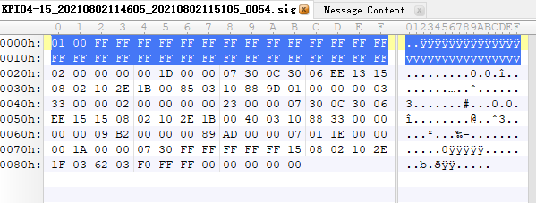

The first signaling data record is used as an example to describe the value and length of each field.

Header Format of Standard Signaling Northbound Result Files

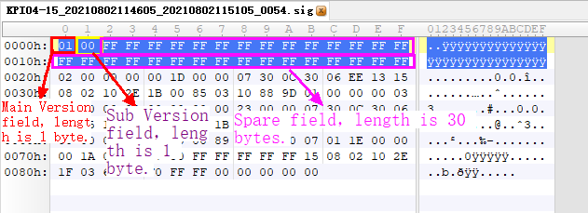

Format of an LTE Standard Signaling Northbound Event Header

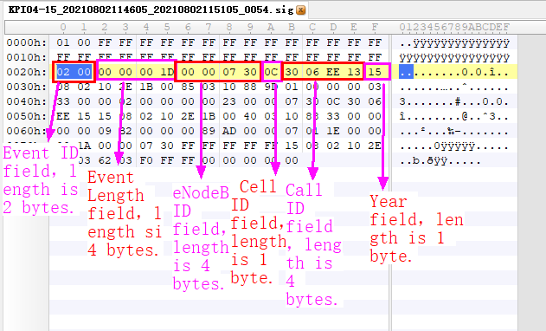

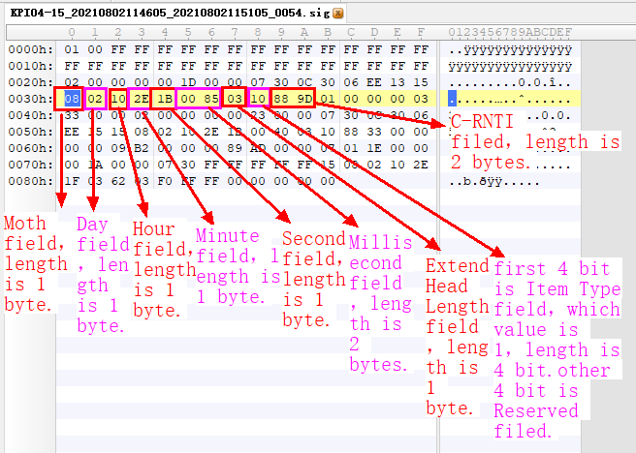

Formats of the LTE Standard Signaling Event Content

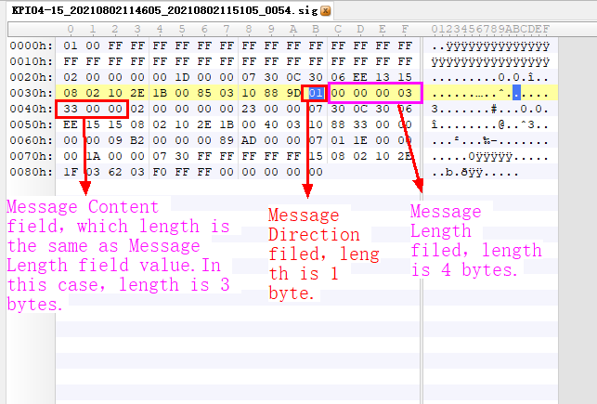

## Parse File as the Guide



Format of LTE northbound result files

| Field | Data Type and Length | Description | Value（Hex） |
| --- | --- | --- | --- |
| Data Version | - | File format version information |  |
| >Main Version | UINT8 | Main version | 0x01 |
| >Sub Version | UINT8 | Sub-version | 0x00 |
| Spare | OCTET STRING (30) | Spare | 30 Bytes 0xFF |

Header format of LTE standard signaling files

| Field | Data Type and Length | Description | Introduced In | Value（Hex） |
| --- | --- | --- | --- | --- |
| Event ID | UINT16 | Event identifier | SRAN11.1  Pico 11.1 | 0x0200 |
| Event Length | UINT32 | Event length, excluding lengths of **Event ID** and **Event Length** | SRAN11.1  Pico 11.1 | 0x0000001D |
| eNodeB ID | UINT32 | eNodeB identifier. | SRAN11.1  Pico 11.1 | 0x00000730 |
| Cell ID | UINT8 | Cell identifier  Invalid value: all Fs. For example, the value of this field is invalid for base station events or cell events. | SRAN11.1  Pico 11.1 | 0x0C |
| Call ID | UINT32 | Call ID  Invalid value: all Fs For example, the value of this field is invalid for base station events. | SRAN11.1  Pico 11.1 | 0x3006EE13 |
| Date Time | - | Time when an event is triggered  UTC time | SRAN11.1  Pico 11.1 |  |
| >Year | UINT8 | Difference between the current year and the year 2000 | SRAN11.1  Pico 11.1 | 0x15 |
| >Month | UINT8 | Month  Value range: 1 to 12 | SRAN11.1  Pico 11.1 | 0x08 |
| >Day | UINT8 | Day  Value range: 1 to 31 | SRAN11.1  Pico 11.1 | 0x02 |
| >Hour | UINT8 | Hour  Value range: 0 to 23 | SRAN11.1  Pico 11.1 | 0x10 |
| >Minute | UINT8 | Minute  Value range: 0 to 59 | SRAN11.1  Pico 11.1 | 0x2E |
| >Second | UINT8 | Second  Value range: 0 to 59 | SRAN11.1  Pico 11.1 | 0x1B |
| >Millisecond | UINT16 | Millisecond  Value range: 0 to 999  The value is **0** for events accurate to seconds. | SRAN11.1  Pico 11.1 | 0x0085 |
| Extend Head Length | UINT8 | Extension header length | - |  |
| Item Type | BIT STRING (4) | Event type.   * **0000**: undefine * **0001**: FDD * **0010**: TDD * **0101**: NB-IoT * **1111**: Common | SRAN13.1 | 0x01 |
| Reserved | BIT STRING (4) | reserved | - | 0x00 |
| C-RNTI | UINT16 | C-RNTI  Invalid value: all Fs. For example, the value of this field is invalid for base station events or cell events. | SRAN11.1  Pico 12.0 | 0x889D |

Format of an LTE standard signaling event header

| Field | Data Type and Length | Description | Introduced In | Value（Hex） |
| --- | --- | --- | --- | --- |
| Message Direction | UINT8 | Message direction  **0**: receive  **1**: send  Invalid value: **FFFFFFFF** | SRAN11.1  Pico 11.1 | 0x01 |
| Message Length | UINT32 | Message length | SRAN11.1  Pico 11.1 | 0x00000003 |
| Message Content | OCTET STRING (Message Length) | Message content If there is a Uu interface message, the first byte indicates the type of the logical channel where the message is sent. Value range: 1: DL DCCH 2: UL DCCH 3: DL CCCH 4: UL CCCH 18: MCCH 30: DL DCCH NB 31: UL DCCH NB 32: DL CCCH NB 33: UL CCCH NB | SRAN11.1  Pico 11.1 | 0x330000 |

Formats of the LTE standard signaling event content

## Sample Data File

